BCSE497J Project-I

SELECTIVE COOKIE OUTSOURCING USING PRIVATE INFORMATION RETRIEVAL

22BCE0756 | APOORVA KARNWAL
22BCE2232 | SHIVESH KAUSHIK

Under the Supervision of
KATHIRAVAN SRINIVASAN
Professor Grade 1
School of Computer Science and Engineering (SCOPE)

B.Tech.
in
Computer Science and Engineering

School of Computer Science and Engineering



September 2025

ABSTRACT
Browser cookies have become a fundamental component of modern web architecture, enabling essential features such as user authentication, session management, personalization, and analytics. While these functions significantly improve user experience, they also create privacy vulnerabilities by exposing individuals to behavioral profiling, cross-site tracking, and potential regulatory violations. The increasing reliance of websites on third-party cookies for targeted advertising and data collection aggravates this issue, leaving users with limited control over how their personal information is collected, stored, and shared. Existing solutions, such as cookie consent banners and Consent Management Platforms (CMPs), primarily address regulatory compliance rather than enforcing strict security controls. Furthermore, there is a growing demand for mechanisms that balance usability, privacy, and performance in cookie management.
This research study proposes a novel hybrid framework that integrates machine learning (ML) classification techniques with Private Information Retrieval (PIR) protocols to provide an effective and practical approach for cookie privacy. To build the dataset cookies are scraped from websites and then paired with their category labels obtained from the CMPs. From each cookie we extract attributes such as HttpOnly, Secure, and SameSite flags, along with other contextual features categorizing cookies into essential, functional, analytics, or marketing types. These features serve as inputs to supervised ML models, including XGBoost, LightGBM and CatBoost, which are trained to identify cookie category with high accuracy.
To address storage and retrieval concerns, the study incorporates a PIR mechanism that securely outsources sensitive cookies to a cloud/local environment. By utilizing homomorphic encryption, the PIR protocol ensures that users can retrieve their data without revealing access patterns or compromising security. Furthermore, recent advances in PIR efficiency, particularly low-communication and high-rate protocols like the Spiral PIR, are leveraged to minimize the latency typically associated with cryptographic methods. The approach proposed in this study makes three key contributions. First, it demonstrates cookie classification using attribute-level and contextual features. Second, it introduces a selective storage mechanism that applies PIR only where necessary, significantly reducing overhead. Third, it offers a scalable and deployable architecture for integrating technical privacy protections within browsers. The expected outcome is a framework that ensures user privacy while maintaining seamless web functionality, making it a promising candidate for adoption in privacy-conscious browser ecosystems.

TABLE OF CONTENTS
Sl.No | Contents | Page No.
 | Abstract
1. | INTRODUCTION | 1
 | 1.1 Background | 1
 | 1.2 Motivations | 4
 | 1.3 Scope of the Project | 4
2. | PROJECT DESCRIPTION AND GOALS | 5
 | 2.1 Literature Review | 5
 | 2.2 Gaps Identified | 6
 | 2.3 Objectives | 6
 | 2.4 Problem Statement | 7
 | 2.5 Project Plan - Gantt Chart, WBS | 7
3. | REQUIREMENT ANALYSIS | 10
 | 3.1 Functional Requirements | 10
 | 3.2 Non-Functional Requirements | 10
 | 3.3 Data Requirements | 10
 | 3.4 User Requirements | 10
 | 3.5 Software Requirements | 11
4. | SYSTEM DESIGN | 11
 | 4.1 Cookie Monitoring & Classification | 11
 | 4.2 Privacy-Aware Storage & Retrieval | 12
5. | REFERENCES | 12

1. INTRODUCTION
The rise of web technologies has reshaped how users access services and information. Central to this evolution is the HTTP cookie, or browser cookie, a lightweight data structure that stores stateful information in an otherwise stateless web environment. Initially, cookies were designed as a convenience for session management, but they have since evolved into a powerful tool that supports authentication, personalization, analytics, and large-scale targeted advertising. While this evolution enables seamless user experiences and improves usability, it has also introduced complex privacy and security concerns.
Cookies often persist beyond a single browsing session, are accessible across domains and often contain sensitive user information such as session tokens. Cookies can be exploited for behavioral profiling, cross-site tracking, masquerading or even session hijacking [1]. Modern regulatory frameworks such as the General Data Protection Regulation (GDPR) [6] in the European Union and the California Consumer Privacy Act (CCPA) in the United States, attempt to mitigate these risks by mandating explicit consent from the users for data collection and cookie acceptance. However, the compliance mechanisms such as cookie banners or Consent Management Platforms (CMPs) frequently prove inadequate and fail to implement the user consent, as studies show that many websites mislabel cookies, ignore user preferences, or employ manipulative "dark patterns" [1,5,6] that steer users toward acceptance.
In this context, the need arises for solutions that go beyond regulatory compliance and provide stronger, practical privacy protections for cookies. Simply blocking cookies is not feasible as it may interfere with website functionality and usability. Recent progress in machine learning (ML) [3,4] for automatic cookie classification, along with advances in Private Information Retrieval (PIR) protocols [8], creates an opportunity for a more balanced approach. Such a system can separate sensitive cookies from non-sensitive ones, protecting only the critical data with cryptographic methods while keeping performance costs low and reducing latency.
This research proposes a framework that combines ML classification of cookies with selective PIR-based storage to achieve privacy-preserving cookie management. The ML models use cookie attributes, HttpOnly, Secure, and SameSite flags, to classify cookies into meaningful categories. Based on these results, only the sensitive cookies are outsourced using PIR protocols, which ensures secure retrieval without revealing user access patterns. This combined strategy improves privacy while still maintaining usability and reduces the overhead created by outsourcing all cookies to the secure server.
1.1 Background
The effectiveness of any privacy-related solutions for cookies requires a deeper understanding of how cookies function, the various attributes and properties of an http cookies, the legal frameworks governing them, and the limitations of current enforcement mechanisms. This section provides the technical and contextual founMantion for the proposed work, beginning with the structure and attributes of cookies, then discussing data protection regulations and consent platforms, and finally highlighting recent advances in machine learning on the topic of cookie classification and Private Information Retrieval (PIR) that motivate a combined approach.
1.1.1 Http Cookies
Http Cookies, also known as browser cookies, are small pieces of data sent from a web server to the user’s browser. Cookies allow web applications to store limited amounts of information about user interactions, making web experiences more seamless and interactive. Cookies enable websites to recognize returning users, maintain session continuity, personalize content, and perform analytics or targeted advertising [3]. This capability to associate requests with a specific user session is fundamental to how the modern web functions.
Cookies serve crucial purposes that enhance the overall user experience and provide websites with valuable data.The primary functions of cookies are as follows: (1) Session management uses cookies to track login status, shopping cart contents, or user progress in web applications. (2) Personalization allows websites to remember user preferences, such as language selection or theme settings (dark or light mode). (3) Tracking and analytics use cookies to monitor browsing behaviour, measure engagement, and support targeted advertising. While cookies were historically used for general client-side data storage, modern alternatives like localStorage, sessionStorage, and IndexedDB are now recommended for larger or non-sensitive data.
The lifecycle of cookie, creation, updation and deletion, is managed through HTTP headers. Server creates cookies by including Set-Cookie header in its response. The user's browser then stores this data and automatically includes it in subsequent requests to the same domain via the Cookie header. Cookies can be either session cookies, which are temporary and are deleted when the browsing session ends, or persistent cookies, which remain on the user's device until a specified expiration date or duration. Developers can update a cookie by sending a Set-Cookie header with the same name but a new value. While cookies can also be managed via JavaScript using Document.cookie, access may be restricted by security attributes like HttpOnly. Improper handling, such as the use of “zombie cookies” that are recreated after deletion, can lead to privacy violations and non-compliance with regulations.
Cookies include several attributes that control their behavior and security. The Domain and Path attributes determine which URLs will receive the cookie. The Secure attribute ensures cookies are transmitted only over HTTPS, preventing interception on unsecured networks. The HttpOnly attribute blocks JavaScript access, reducing exposure to cross-site scripting (XSS) attacks. The SameSite attribute helps prevent cross-site request forgery (CSRF) and limits third-party cookie exposure, with values such as Strict, Lax, or None defining the scope of cross-site access. Additionally, cookie prefixes like __Secure- and __Host- enforce stricter security rules, ensuring cookies are set on secure origins with limited scope and reducing risks from session fixation or subdomain misuse.

1.1.2 Data Protection Regulations
The General Data Protection Regulation (GDPR), in force across the EU since 2018, is one of the strictest global privacy laws [5]. It mandates explicit, informed consent before personal data, including cookies, can be processed. Non-compliance carries heavy penalties of up to €20 million or 4% of worldwide turnover, compelling websites to implement consent banners and stricter cookie handling.
The California Consumer Privacy Act (CCPA), effective from 2020, gives residents of California rights to know, opt out of, and request deletion of personal data. Cookies are covered under its definition of personal information. Unlike GDPR’s opt-in approach, CCPA follows an opt-out model, requiring users to take action if they do not want their data shared, especially for advertising purposes.
Despite these frameworks, enforcement challenges remain. Across all three regions, compliance often relies on banners or CMPs that may be misleading, poorly implemented, or ignored by websites. Users, confronted with frequent pop-ups, often default to “accept all,” [1,6] undermining the intended protections and leaving privacy risks unresolved.
1.1.3 Consent Management Platforms (CMPs)
Consent Management Platforms (CMPs) were developed to help website operators comply with regulations like GDPR and CCPA. CMPs automate the collection of user preferences and ensure these choices are communicated to third-party vendors. Well-known examples include OneTrust and Cookiebot.
CMPs offer several strengths. They reduce the compliance burden for website owners and provide standardized mechanisms, such as those defined by the IAB’s Transparency and Consent Framework (TCF). By centralizing consent management, CMPs also simplify integration across multiple advertising and analytics platforms.
However, CMPs also face weaknesses. Many uses dark patterns pressuring users into accepting all cookies [1,5,6]. Others fail to respect explicit rejection signals, continuing to set non-essential cookies despite a user’s choice. In practice, adoption of CMPs remains limited, with studies reporting that fewer than 3% of top websites deploy them effectively [5]. As a result, CMPs are better viewed as compliance aids rather than robust privacy enforcement systems.
1.1.4 Machine Learning for Cookie Classification
Machine learning (ML) provides a systematic approach for automating cookie classification. By analyzing cookie attributes such as HttpOnly, Secure, and SameSite flags, along with the contextual metadata, ML models can predict the functional category of a cookie, whether, for example, between essential, functional, analytical, and tracking cookies.
Previous research has demonstrated the feasibility of this approach [3,4]. For instance, the CookieBlock project successfully applied gradient-boosting classifiers such as XGBoost and CatBoost to classify cookies with higher accuracy than public repositories like Cookiepedia [6]. These models have proven capable of recognizing subtle attribute patterns that humans or rule-based systems may overlook.
That said, ML-based classification has clear limitations. While it can effectively detect and categorize cookies, classification alone does not enforce security or privacy policies. Without an accompanying mechanism to control storage and retrieval, sensitive cookies remain vulnerable to misuse once identified [7].
1.1.5 PIR - Private Information Retrieval
Private Information Retrieval (PIR) is a cryptographic technique that enables a client to query a database and retrieve a record without revealing which record was accessed. This ensures that the server storing the data cannot infer the user’s interests or activities from their requests.
Historically, PIR faced significant performance challenges. Early protocols imposed heavy computational and communication costs, making them impractical for real-time applications such as web browsing[8]. As a result, PIR was mostly limited to theoretical discussions.
Recent advances, however, have transformed the landscape. Developments in homomorphic encryption and optimized PIR schemes, including high-rate protocols proposed in 2023 [9], have reduced latency and bandwidth requirements. These improvements make PIR a practical option for securing sensitive web interactions. Within the scope of this project, PIR provides a means to outsource sensitive cookies to a secure storage environment, ensuring they can be retrieved when needed without exposing patterns or compromising confidentiality [8,9].
1.2 Motivations
Cookies are vital for authentication, personalization, and analytics but are often misused for tracking, profiling, and cross-site surveillance, creating serious privacy risks. Existing compliance measures like consent banners and CMPs are inadequate, as they are frequently misimplemented, misleading, or ignored, leaving users vulnerable and eroding trust.
Completely blocking cookies is impractical since it disrupts essential web functionality. Hence, there is a need for solutions that balance privacy with usability and performance. Advances in machine learning (ML) for cookie classification and cryptographic methods like Private Information Retrieval (PIR) provide an opportunity to build a scalable framework that offers strong technical privacy protections while preserving seamless web experiences.
1.3 Scope of the Project
This project develops a hybrid framework for cookie privacy by combining machine learning (ML) classification with Private Information Retrieval (PIR). Cookies are collected with attributes like HttpOnly, Secure, SameSite, and expiry, then classified into essential, functional, analytical, or tracking types using gradient-boosting models such as XGBoost and CatBoost. Sensitive cookies are outsourced to secure storage via efficient PIR protocols (e.g., Spiral PIR), while non-sensitive ones remain local to reduce overhead. The framework aims to balance privacy, usability, and performance, and will be evaluated for accuracy, latency, efficiency, and scalability to support integration into browsers or privacy-focused platforms.
2. PROJECT DESCRIPTION AND GOALS
2.1 Literature Review
Berens et al. (2024) provide how using consent banners on website to store cookies is fragile. Through the study the authors show that visual layout of accept/reject banner of cookies strongly influence whether people accept cookies. Many users click “accept” out of habit, fear of site breakage or time, indicating most do not read the banner text. Crucially the paper finds that 70% of the 376 sites still set non-essential cookies even when the user refuses them. This demonstrates how consent UI is quite ineffective and how the cookies are being stored even after refusal.
Bouhoula et al. (USENIX Security,2023) scale the problem up by building a crawler that interacts with cookie banners across 97,000+ targeted websites and use NLP to infer purpose of consent. The study confirms that there is a widespread non-compliance, and the websites choose to not show reject option . The paper also discusses openWPM based crawling with interactive element detection.
Hu et al. (WebSci 2021) introduce CookieMonster, an efficient ML system that classifies cookies using lexical features of cookie names. Their approach shows surprisingly strong performance: simple tokenization and lightweight classifiers produced high F1 scores. The paper also notes limitations—cookie names can be misleading and classification coverage depends on the underlying labeled database. For our work, CookieMonster suggests that fast, name-based classification can be a valuable first stage.
Munir et al. (CCS 2023) address a growing evasion technique: trackers moving to first-party cookies as browsers clamp down on third-party cookies. Their study build a graph-based approach with JavaScript execution traces, network traffic, and storage access to detect first party tracking cookies. This paper tells us that lexical analysis alone is not enough behavioral and network features matter, especially as tracking strategies evolve as well as the cookie attributes.
Sivan-Sevilla et al. (2025) analyze “cookie-less” first-party identity solutions (universal IDs, onboarding approaches) can also result in surveillance risks. This paper helps frame the adversarial landscape: even if browsers remove third-party cookies, tracking shifts and persistence remains a concern. This leads to the need of more secure environment and prevention of user tracking .
Vithana et al. (2023) provide a comprehensive PIR survey that lays out the practicality trade-offs between multi-server information-theoretic PIR and single-server computational PIR (often using homomorphic encryption), as well as advanced variants like batched PIR and PIR with side information. The survey is clear about the main bottleneck likes communication and computation costs which directly indicates to choose which PIR method for our case.
Luo and Wang (2025) introduce Faster Spiral, an optimized variant of the well-known Spiral PIR protocol, designed to improve throughput without sacrificing its key strengths of low communication and high retrieval rate. Implemented in C++, these optimizations deliver around 1.7× faster performance compared to the original Spiral, while maintaining small query sizes (14 KB) and high throughput. The paper shows that PIR can be used for more practical scenarios where there are constraints.
2.2 Research Gaps
Across all the above papers we derive that the user-facing consent mechanisms are ineffective, auditing shows systematic non-compliance. While banners and Consent Management Platforms (CMPs) are meant to empower users, they are routinely undermined by manipulative design patterns and backend practices that continue to set non-essential cookies even after explicit rejection. The machine learning based cookies classification offers accuracy but and do not provide a pathway for protecting sensitive cookies once identified. Furthermore, cryptographic tools like Private Information Retrieval provide strong theoretical privacy but lack practical implementations.
What missing is a combined approach that can reliably identify genuine privacy sensitive cookies using lexical, attribute-based and contextual signals and securely store them in a practical manner. Our study addresses this gap through a hybrid machine learning + selective PIR architecture. Our study leverages practical classification models ( like CookieGraph and CookieMonster ), creating labelled dataset via automated CMP parsing (Bouhoula et al.) and applying PIR to sensitive cookies (building on Vithana et al. and Luo et al.).
2.3 Objectives
The primary objective of this research is to design and evaluate a hybrid framework that enhances privacy in cookie management by combining machine learning (ML)-based classification with Private Information Retrieval (PIR) protocols. To achieve this, cookies are collected from real-world websites and enriched with technical attributes such as HttpOnly, Secure, SameSite, and expiry, as well as contextual metadata derived from consent management platforms. These features provide the foundation for training supervised ML models, including XGBoost, LightGBM, and CatBoost, to categorize cookies into essential, functional, analytical, and tracking types. By systematically classifying cookies, the framework aims to distinguish those that are privacy-sensitive and require additional protections.
Beyond classification, the objective extends to designing a selective storage and retrieval mechanism that secures sensitive cookies through optimized PIR protocols while leaving non-sensitive cookies stored locally. This selective outsourcing ensures that cryptographic methods are applied only where necessary, reducing both latency and computational overhead. In doing so, the framework not only strengthens privacy guarantees but also preserves usability and performance. Ultimately, the research seeks to provide a deployable architecture that balances efficiency, scalability, and privacy, with the long-term goal of enabling integration into browsers or privacy-focused platforms for stronger technical protections against misuse of cookies.

2.4 Problem Statement
HTTP cookies are essential for web functionality, supporting authentication, session management, personalization, and analytics, but they have also become tools for tracking, profiling, and unauthorized data collection. Regulatory mechanisms like cookie banners and CMPs focus on compliance rather than on enforcement, with studies showing that a majority of websites still set non-essential cookies even after explicit rejection. Blocking cookies entirely disrupts website usability, while existing technical solutions fail to balance privacy with functionality, often applying one-size-fits-all protections that ignore the different roles of various cookie types.
The central challenge is the lack of an intelligent, practical system that can distinguish between essential and privacy-sensitive cookies at scale and apply selective protections without introducing prohibitive overhead. Machine learning offers accurate classification, but on its own cannot enforce security, while cryptographic methods like PIR ensure privacy but impose high performance costs if applied universally. This project addresses the gap by proposing a hybrid ML + PIR framework that automatically classifies cookies into functional categories and applies efficient PIR protocols only to sensitive cookies, ensuring privacy protection without sacrificing usability or performance.
2.5 Project Plan
Step 1: Data Collection
- Search for existing labeled cookie datasets for benchmarking
- Scrape a domain list of top websites from Cookiepedia
- Use OpenWPM integrated with Consent-O-Matic to detect CMPs (Consent Management Platforms) across domains
- Extract a list of domains with active CMPs
- Fetch cookie categorization labels directly from CMPs
- Crawl each website by accepting all cookies to obtain raw cookie datasets

Step 2: Data Preprocessing
- Remove duplicate cookies across domains
- Normalize domain names (e.g., “.google.com” → “google.com”)
- Perform logical joins on cookie name and domain to link cookies with CMP-provided labels
- Convert boolean cookie attributes into binary values (true → 1, false → 0)
- Extract contextual features such as expiry time, first-party/third-party classification, and other metadata
- Encode categorical features (e.g., top-level domain, SameSite values) into numerical form for ML models
Step 3: Machine Learning Model Development
- Split the labeled dataset into training and testing subsets
- Train supervised ML models such as XGBoost, LightGBM, and CatBoost on cookie attributes and contextual features
- Compare model performance and select the best-performing classifier
- Evaluate using accuracy, precision, recall, and F1-score to ensure balanced performance
Step 4: PIR Integration
- Select the appropriate PIR protocol type: Computational PIR (single-server) or Information-Theoretic PIR (multi-server)
- Implement the chosen PIR scheme using homomorphic encryption or optimized Spiral PIR variants
- Test secure storage and retrieval of sensitive cookies
- Integrate PIR-based storage with ML outputs, applying PIR only to privacy-sensitive cookies
- Prototype integration into a browser extension or middleware for proof-of-concept deployment
Step 5: Evaluation and Validation
- Measure system performance in terms of classification accuracy, latency, and efficiency
- Evaluate network and bandwidth overhead of PIR retrieval
- Conduct privacy and security assessments to ensure compliance with GDPR and CCPA
- Compare results against baseline methods such as cookie blocking and CMP-only consent mechanisms
- Document implementation details, experimental results, and write the final report

2.5.1 Gannt Chart
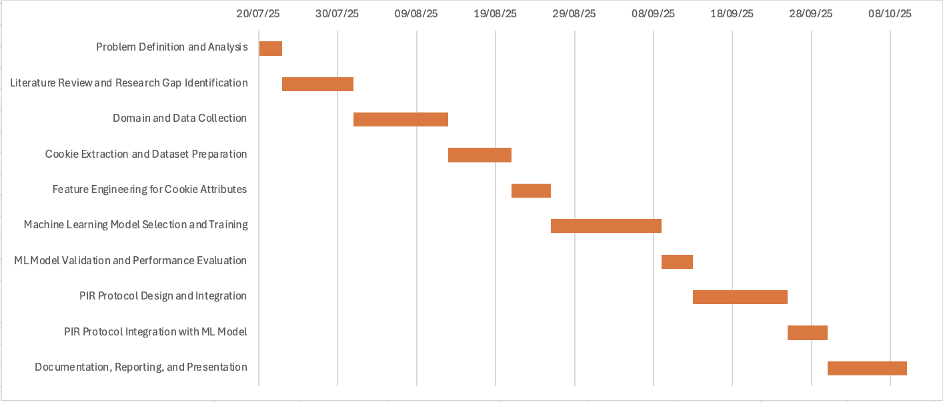

2.5.2 Work Breakdown Structure
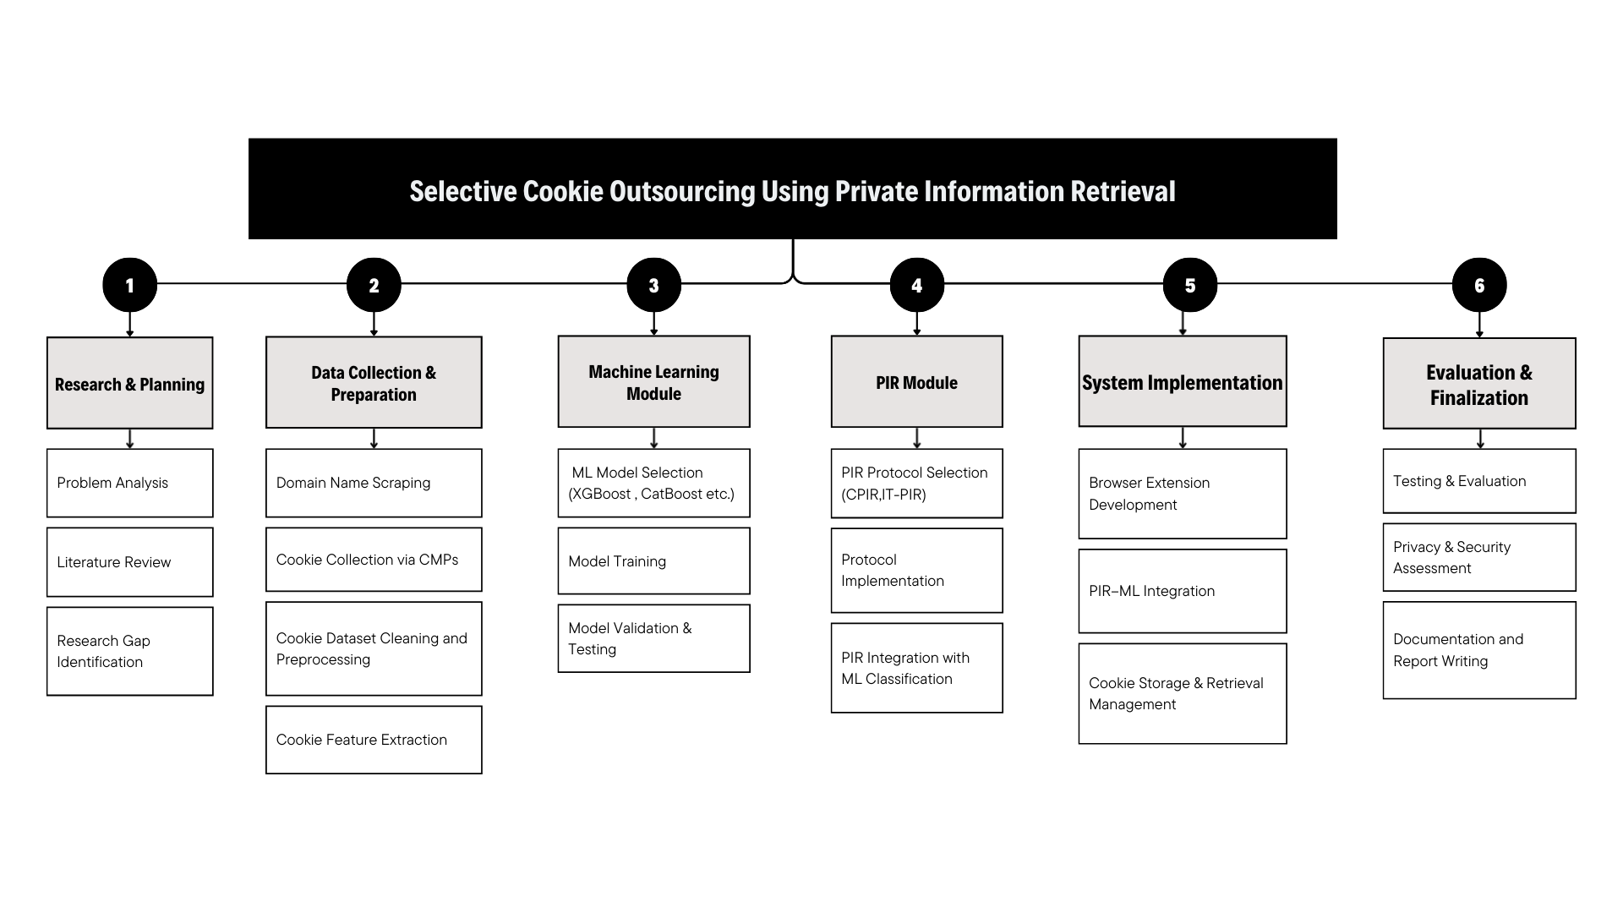

3. REQUIREMENT ANALYSIS
3.1 Functional Requirements
- System must automatically crawl and collect cookies from real-world websites using OpenWPM or similar tools.
- Extract and preprocess cookie attributes (e.g., HttpOnly, Secure, SameSite, expiry) along with contextual metadata from CMPs.
- Train supervised ML models (XGBoost, LightGBM, CatBoost) for cookie classification into categories: essential, functional, analytics, marketing.
- Implement selective storage of sensitive cookies using PIR protocols, ensuring secure retrieval without revealing access patterns.
- Provide a scalable and modular architecture for integrating cookie classification and PIR into browser or middleware environments.
- Visualize classification results, storage statistics, and privacy improvements.
3.2 Non-Functional Requirements
- Performance: The system should process and classify cookies with minimal latency.
- Scalability: Must support large-scale web crawling across thousands of domains.
- Reliability: Ensure robust handling of dynamic websites, CMP variations, and malformed cookies.
- Usability: Framework should be deployable in browser extensions or lightweight middleware with minimal disruption to browsing.
3.3 Data Requirements
- Cookie Dataset: Collected from large-scale crawling (including attributes, domain metadata, expiry, flags).
- CMP Data: Extracted labels from Consent Management Programs for supervised training.
- Training Data: Structured features for ML models, stored in CSV/JSON formats.
- Storage Data: Sensitive cookies encrypted and outsourced via PIR, while non-sensitive cookies stored locally.
3.4 User Requirements
- End-users or web users should experience seamless browsing without noticeable performance loss.
- Users must retain control over cookie preferences while benefiting from stronger technical privacy enforcement.
- Researchers and developers should be able to extend the framework by swapping ML models or PIR schemes.

3.5 Software Requirements
- Programming Language: Python 3.9+
- Libraries: requests, beautifulsoup4, lxml (web scraping); OpenWPM (data collection); pandas, numpy (data handling); scikit-learn, sentence-transformers, (ML and retrieval); matplotlib (visualization); cryptography (PIR protocol implementation)
- Databases/Storage: SQLite for structured cookie data; JSON/CSV for datasets
- Tools: Git/GitHub (version control), Docker (reproducible setup)

4. SYSTEM DESIGN

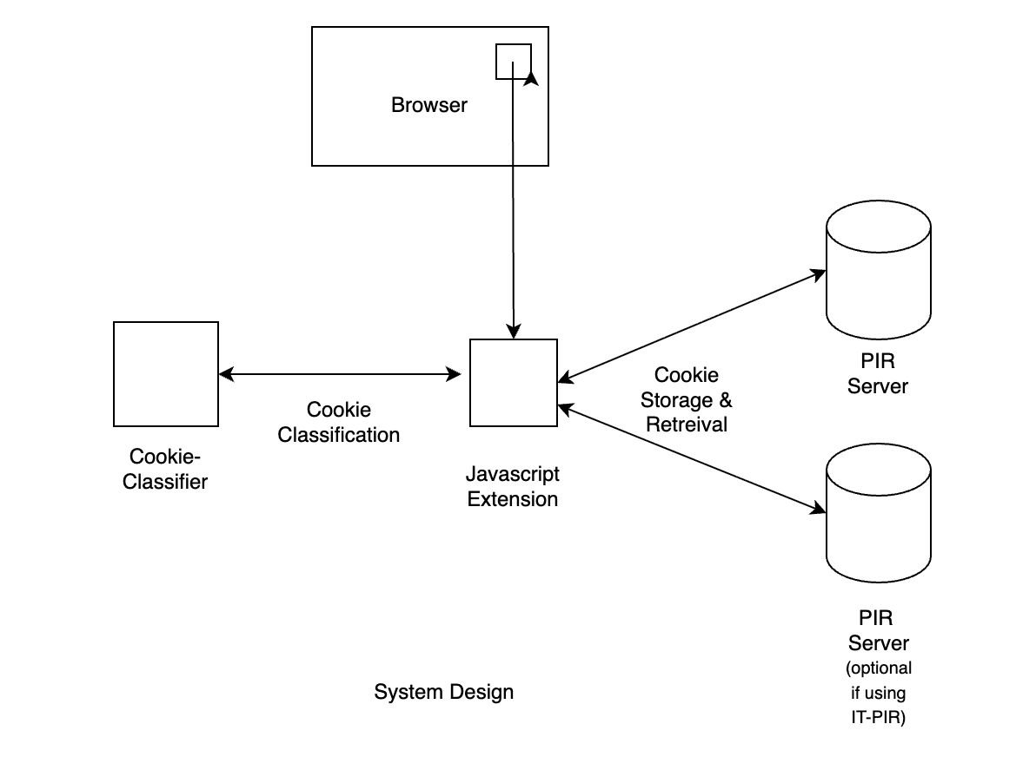

4.1 Cookie Monitoring and Classification
A browser extension acts as the client agent, observing cookies as they are set or accessed. It captures attributes (HttpOnly, Secure, SameSite), contextual metadata (domain, third/first-party, expiry, script source), and lexical features (name tokens, entropy). These features are processed by a hybrid ML pipeline: a lightweight lexical model for fast filtering and a contextual/behavioral model for complex cases. The classifier outputs a cookie category (essential, functional, analytics, marketing) along with a sensitivity score, enabling selective handling.

4.2 Privacy-Aware Storage and Retrieval
Based on classification, non-sensitive cookies are cached locally to preserve performance, while sensitive cookies are encrypted and outsourced to PIR-enabled storage. Homomorphic encryption or optimized protocols like Spiral PIR ensure secure retrieval without revealing access patterns. A policy engine governs which cookies are outsourced, minimizing overhead. A simple dashboard provides users with visibility, override options, and short explanations for classification outcomes.
5. REFERENCES
[1] Berens, B. M., Bohlender, M., Dietmann, H., Krisam, C., Kulyk, O., & Volkamer, M. (2024). Cookie disclaimers: Dark patterns and lack of transparency. Computers & Security, 135, 103507.

[2] Kosztyán, Z. T., Király, T., Csizmadia, T., Katona, A. I., & Vathy-Fogarassy, Á. (2025). Automated research methodology classification using machine learning. Engineering Applications of Artificial Intelligence, 132, 107007.

[3] Hu, X., Sastry, N., & Mondal, M. (2021). Corralling cookies into categories with CookieMonster. In Proceedings of the ACM Web Science Conference (WebSci ’21) (pp. 56–65). ACM.

[4] Munir, S., Siby, S., Iqbal, U., Englehardt, S., Shafi, Z., & Troncoso, C. (2023). Understanding and detecting first-party tracking cookies. In Proceedings of the 2023 ACM SIGSAC Conference on Computer and Communications Security (CCS ’23) (pp. 2345–2360). ACM.

[5] Bouhoula, A., Kubicek, K., Zac, A., Cotrini, C., & Basin, D. (2023). Automated large-scale analysis of cookie notice compliance. In 32nd USENIX Security Symposium (USENIX Security 23) (pp. 4069–4086). USENIX Association.

[6] Bollinger, D., Kubicek, K., Cotrini, C., & Basin, D. (2022, August). Automating cookie consent and GDPR violation detection. In 31st USENIX Security Symposium (USENIX Security 22) (pp. 2893–2910). USENIX Association.

[7] Sivan-Sevilla, I., Parham, P., & McGuigan, L. (2025). ‘Cookie-less’ identification for/against privacy? Internet Policy Review, 14(3).

[8] Vithana, S. V., Wang, Z., & Ulukus, S. (2023). Private information retrieval and its applications. arXiv.

[9] Luo, M., & Wang, M. (2025). Faster Spiral: Low-communication, high-rate private information retrieval. Cryptography, 9(1), 13

